**User Manual of Housing Application**

We have to run the application by clicking the run option which is as shown below.

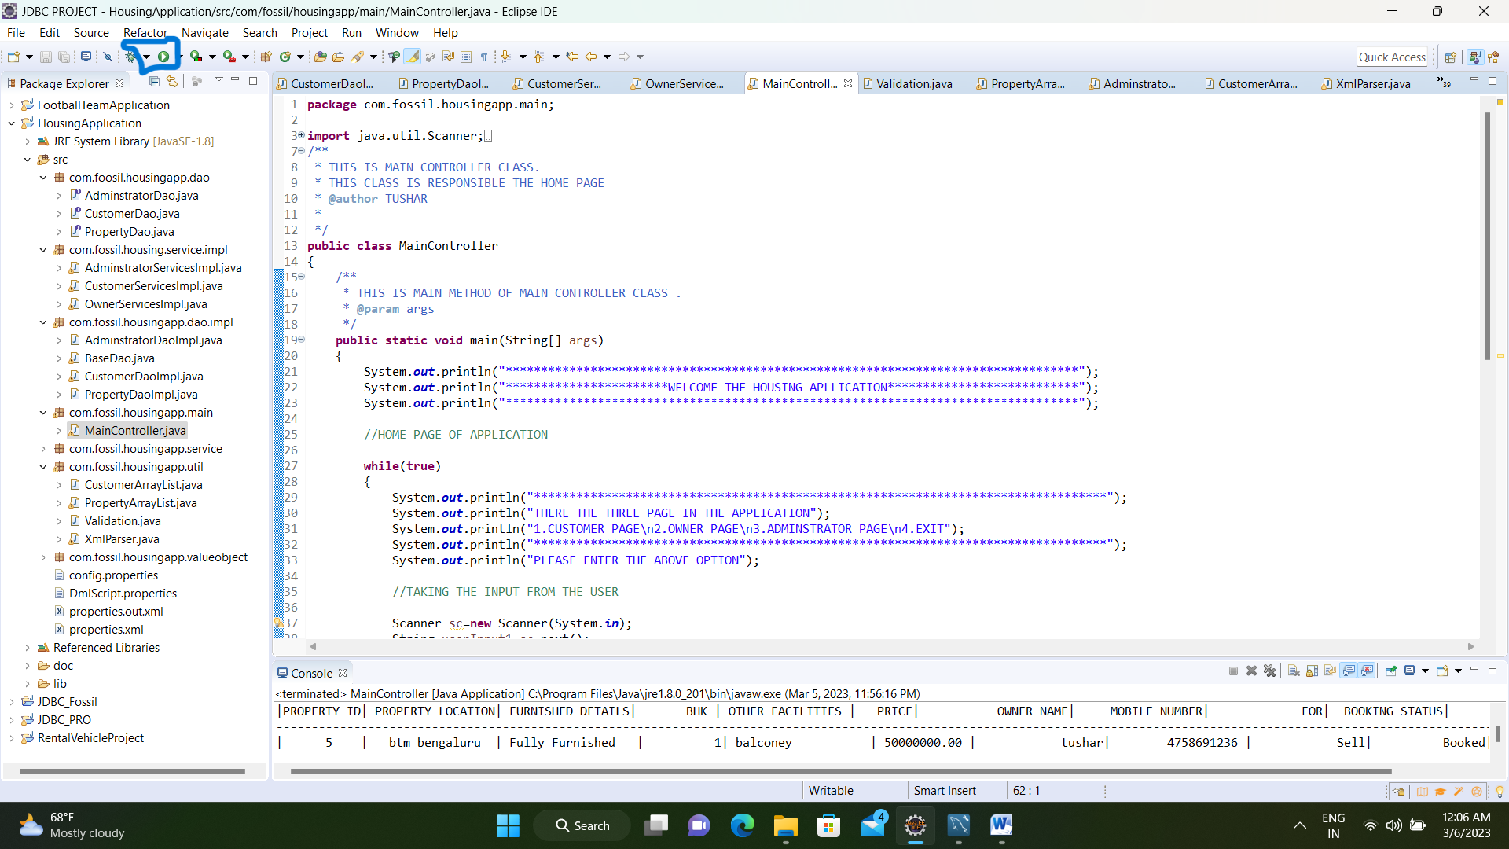

we get a menu regarding the functionalities provided by the application

1. CUSTOMER’S PAGE
2. OWNER’S PAGE
3. ADMINISTRATOR’S PAGE
4. EXIT

All the above option is related to that name for example

1. CUSTOMER’S PAGE is related to customer. Customer can rent or purchase the listed property in our page through this page after registration or login .
2. OWNER’S PAGE is related to owner. Owner can add his property in our application through this page .
3. ADMINISTRATOR’S PAGE is related to administrator. Administrators can see the listed Customer, listed property, delete customer, delete property ,add property from XML file through this page.
4. For exit or stop the application

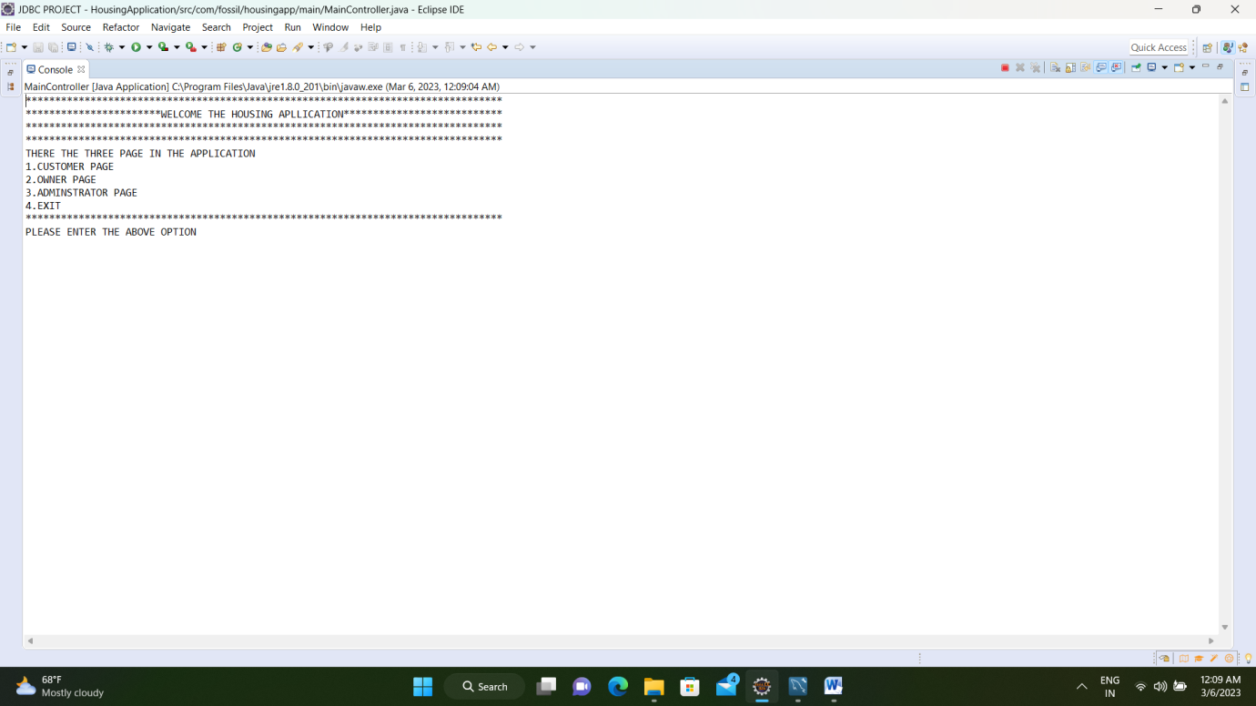

Then according to the functionality to be performed u have to enter the option number present beside every function.

**1. CUSTOMER’S PAGE**

If we choose the 1 option we will get registration or login page .if you want to book property you have to registration or login first .

This page asking customer name ,customer email Id and mobile number If this is new customer .Customer Registered and if already registered this mobile number directly login through this mobile number

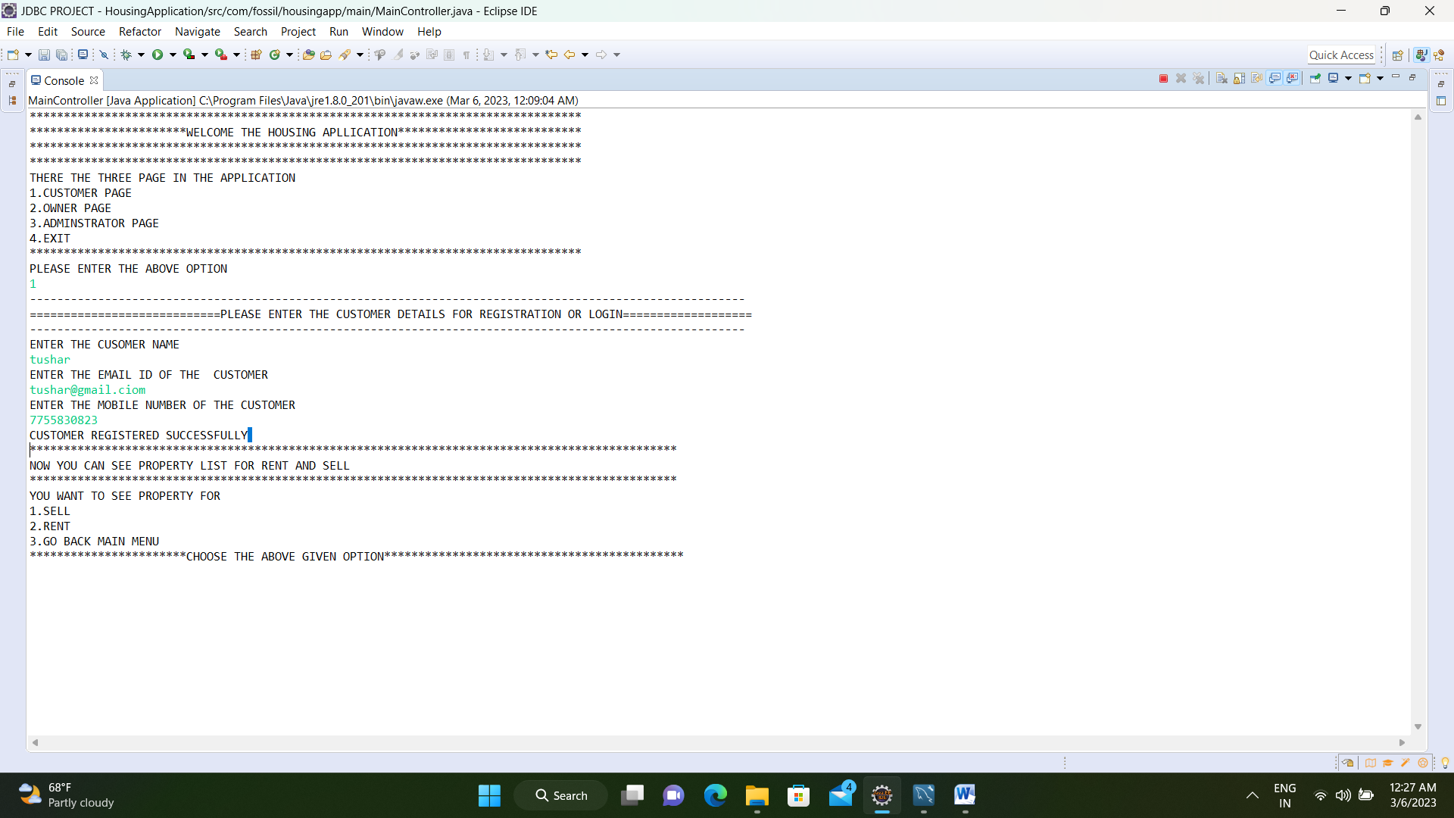

After registered and login you can see listed property

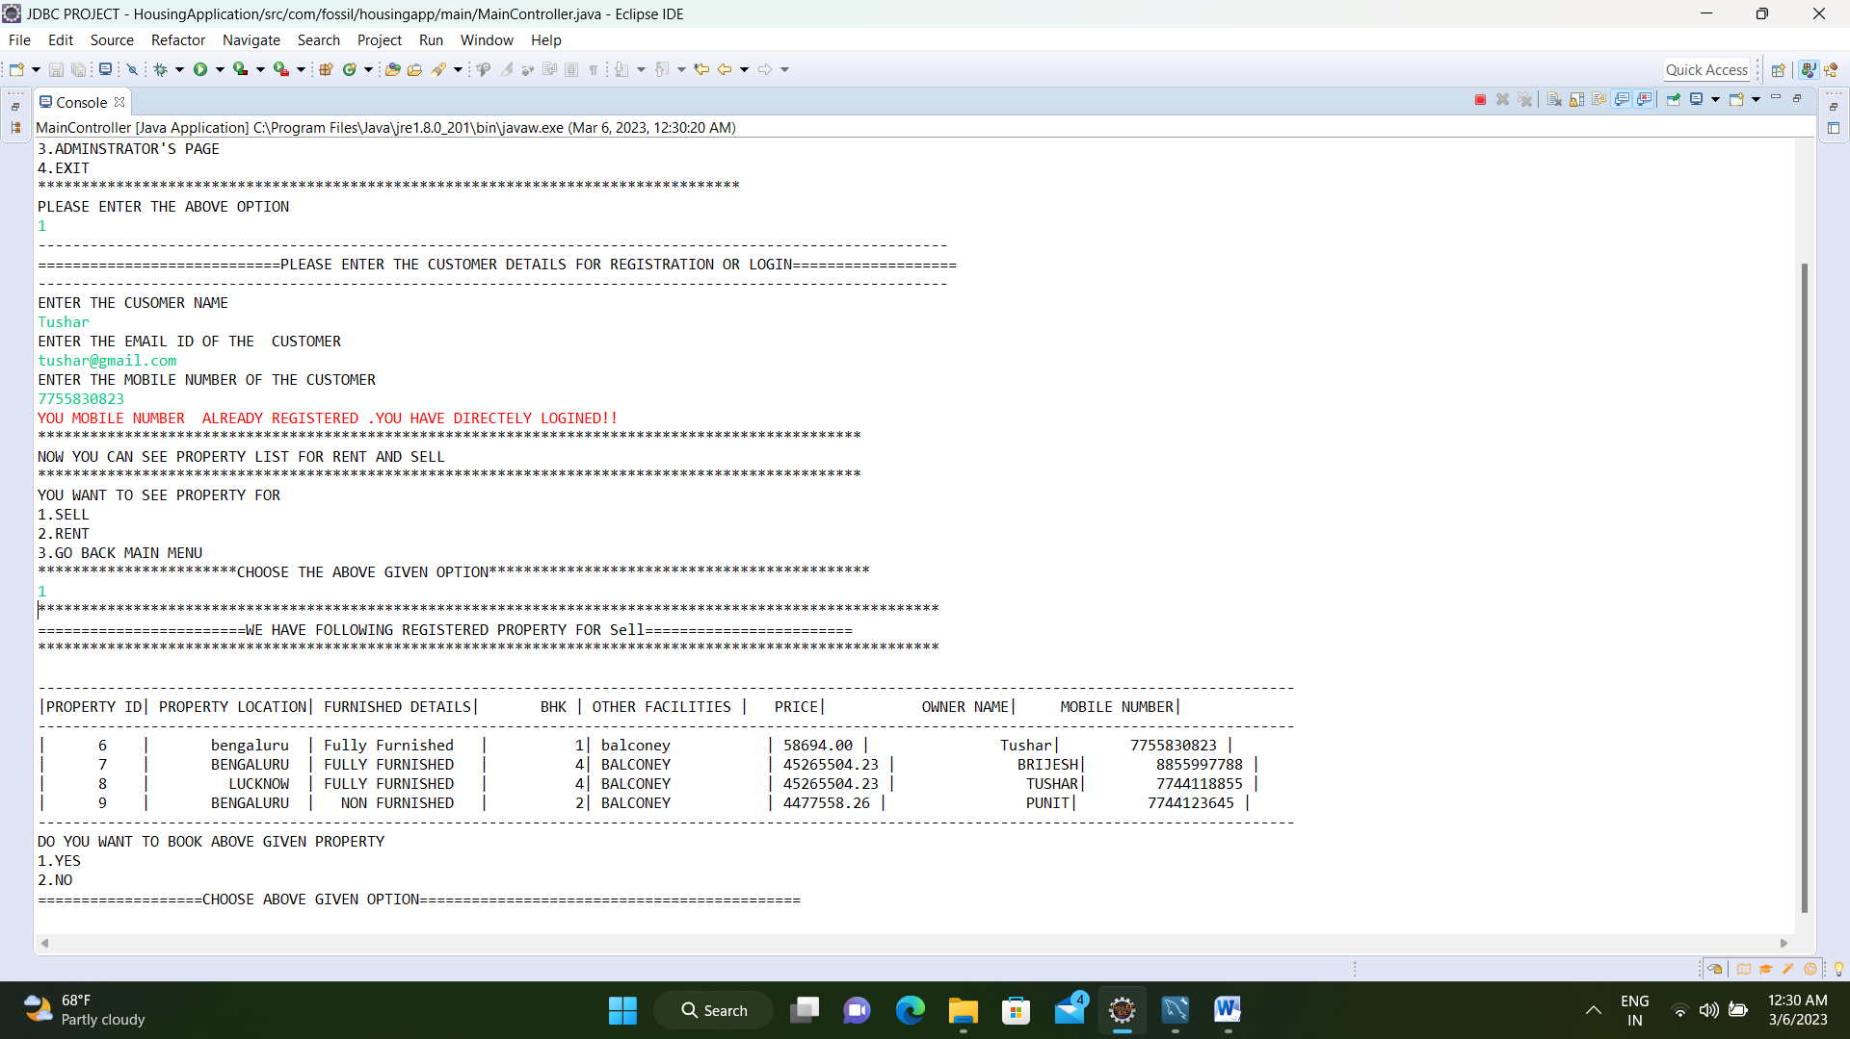

After checking property details asking you want to book property yes or no

If choose yes asking please enter Property Id which you want to book .

After entering correct property Id message display

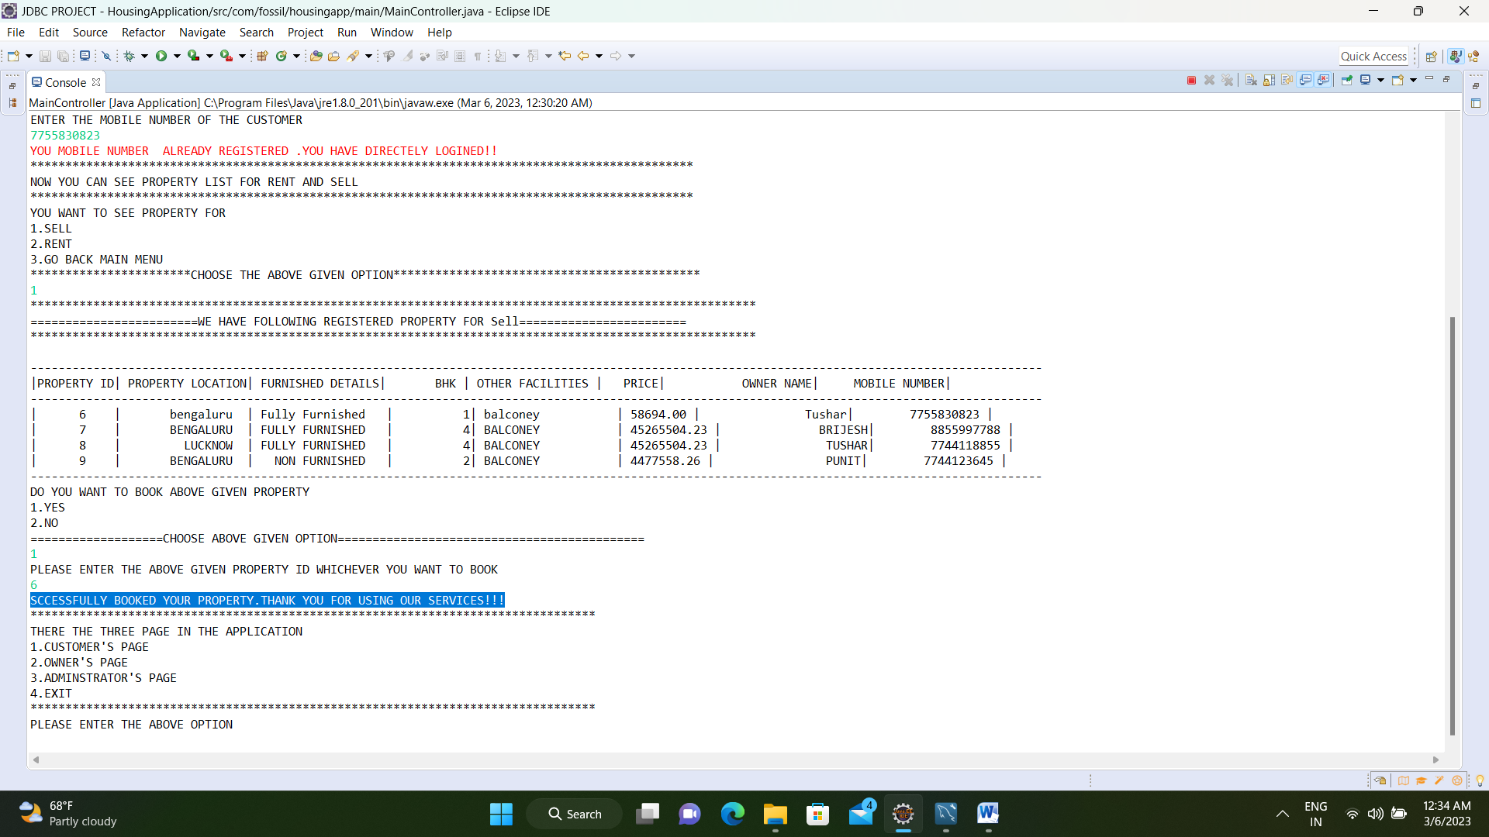

**2. OWNER’S PAGE**

This page is related to owner .Owner can add his property through this page .owner have to enter one by one all the details about property as shown in below figure

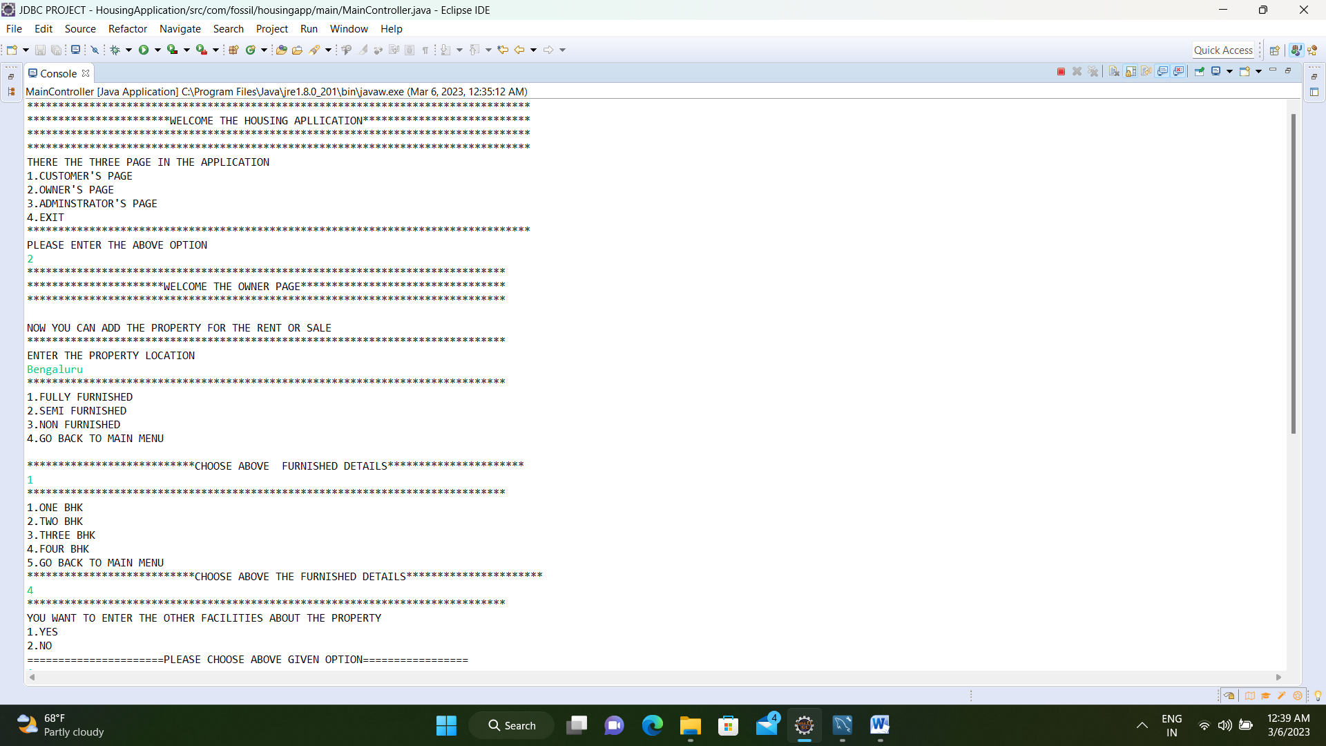

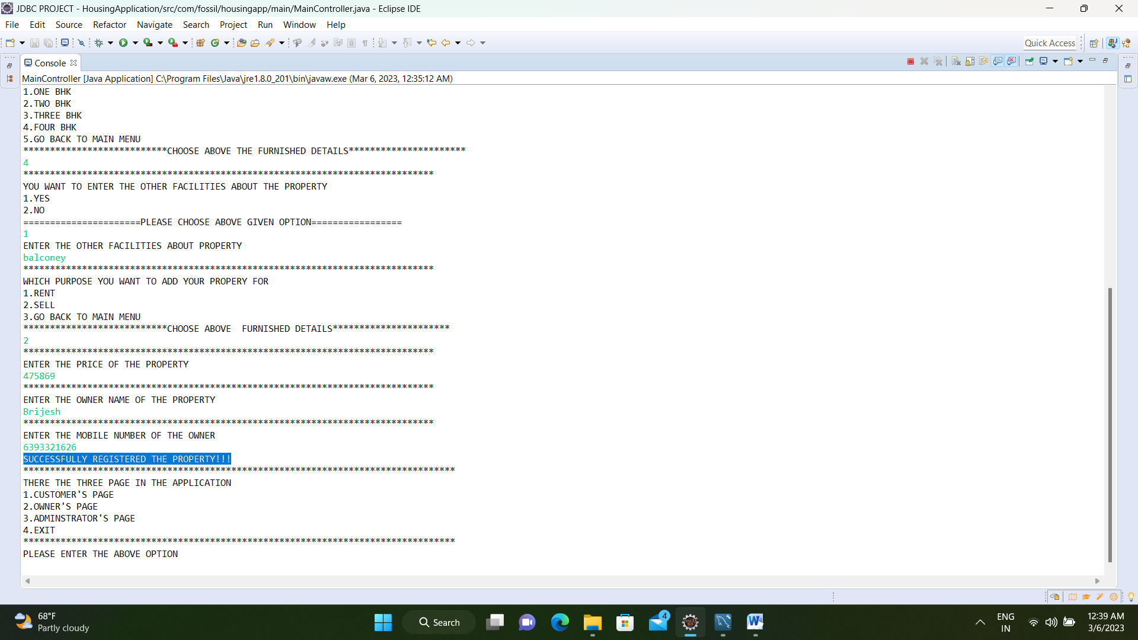

**3. ADMINISTRATOR’S PAGE**

This Page is related to Administrator. Administrator can see listed property , listed customer,

delete customer from list, delete property from list and add property from XML file

**(i)List of Registered customer**

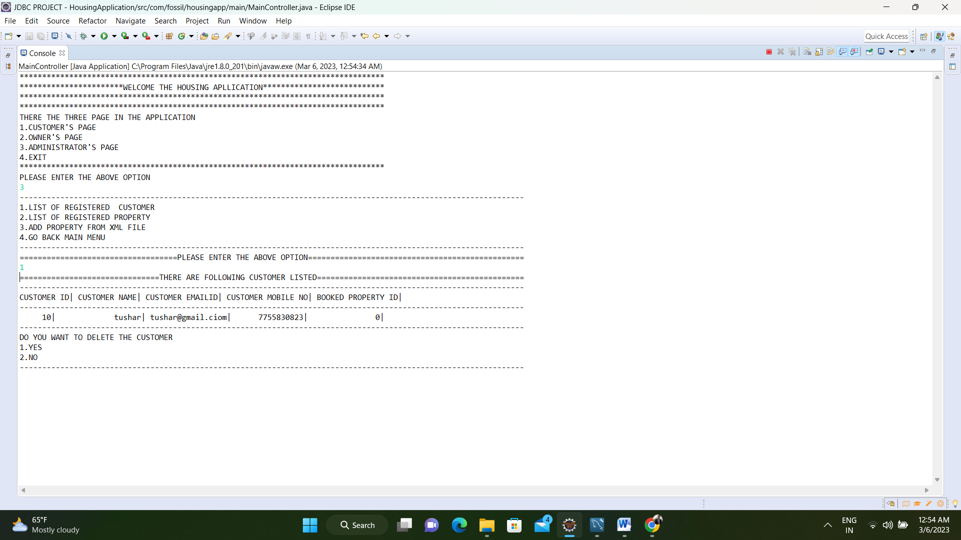

After display all the listed customers. You can delete customer from list as shown in the figure.

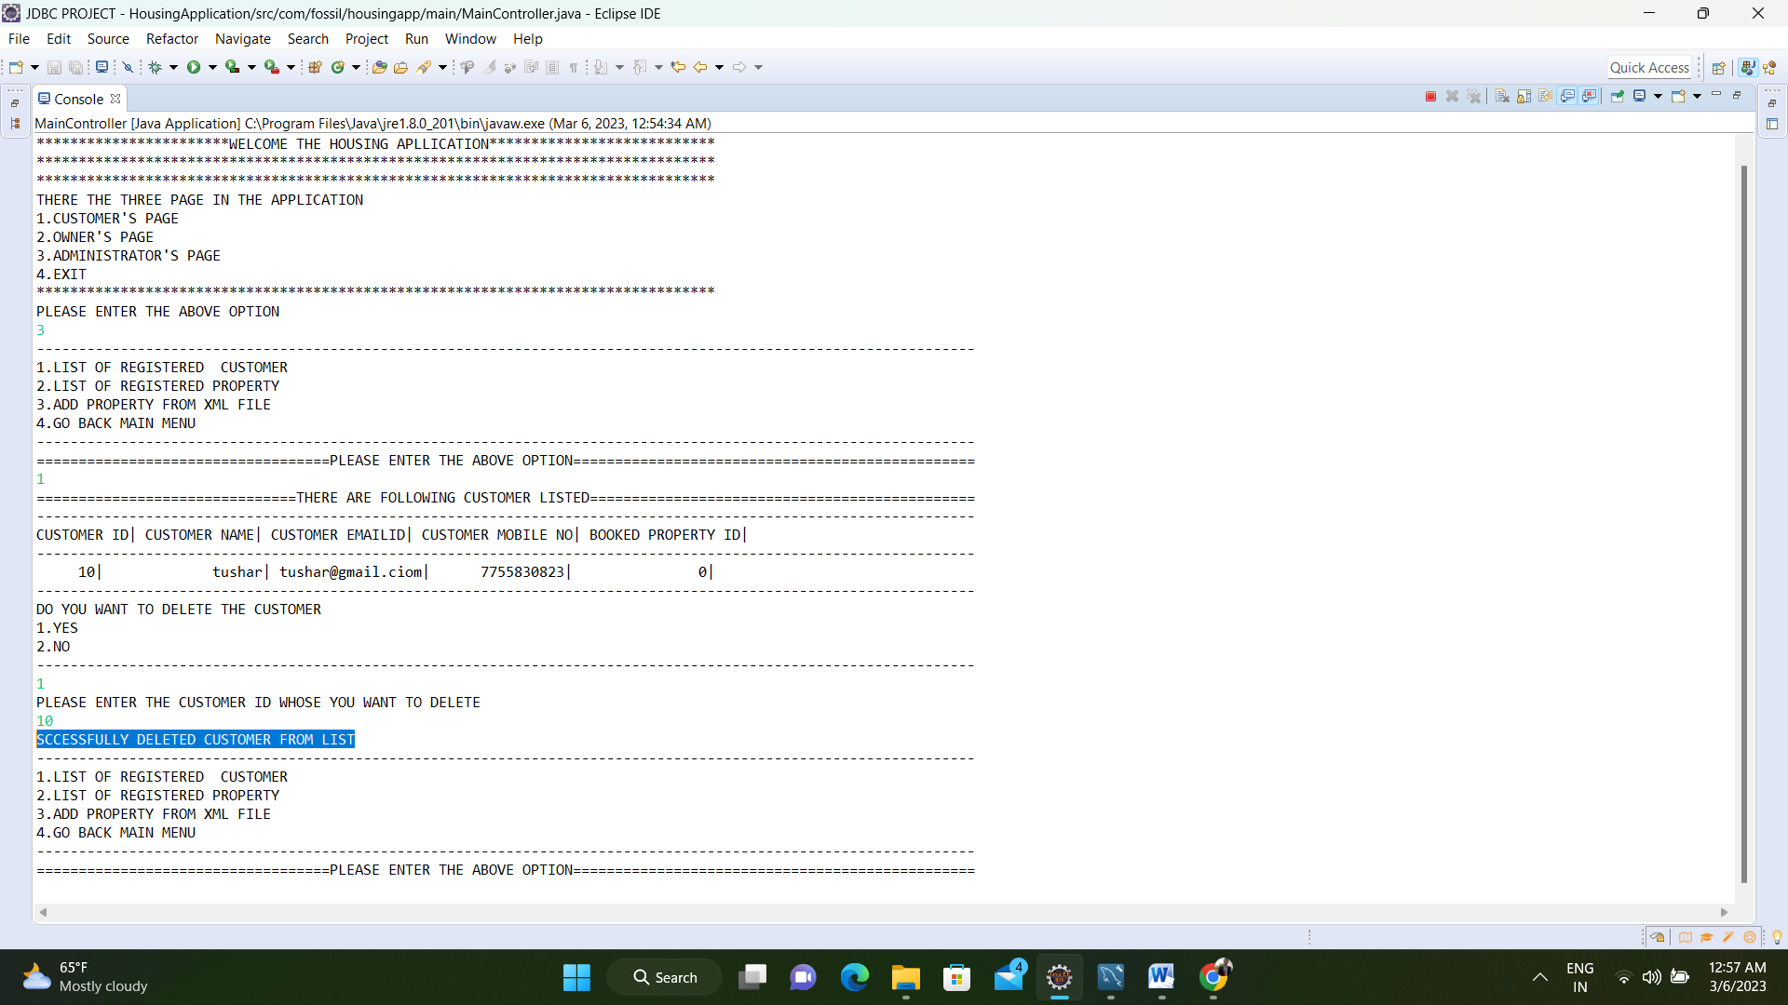

**(ii)List of Registered Property**

After display all the listed property. You can delete property from list as shown in the figure.

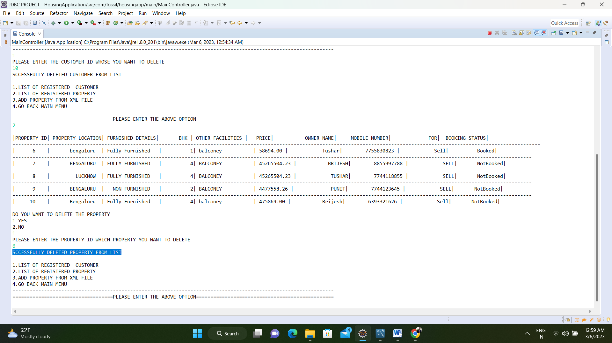

**(iii) add property from XML file**

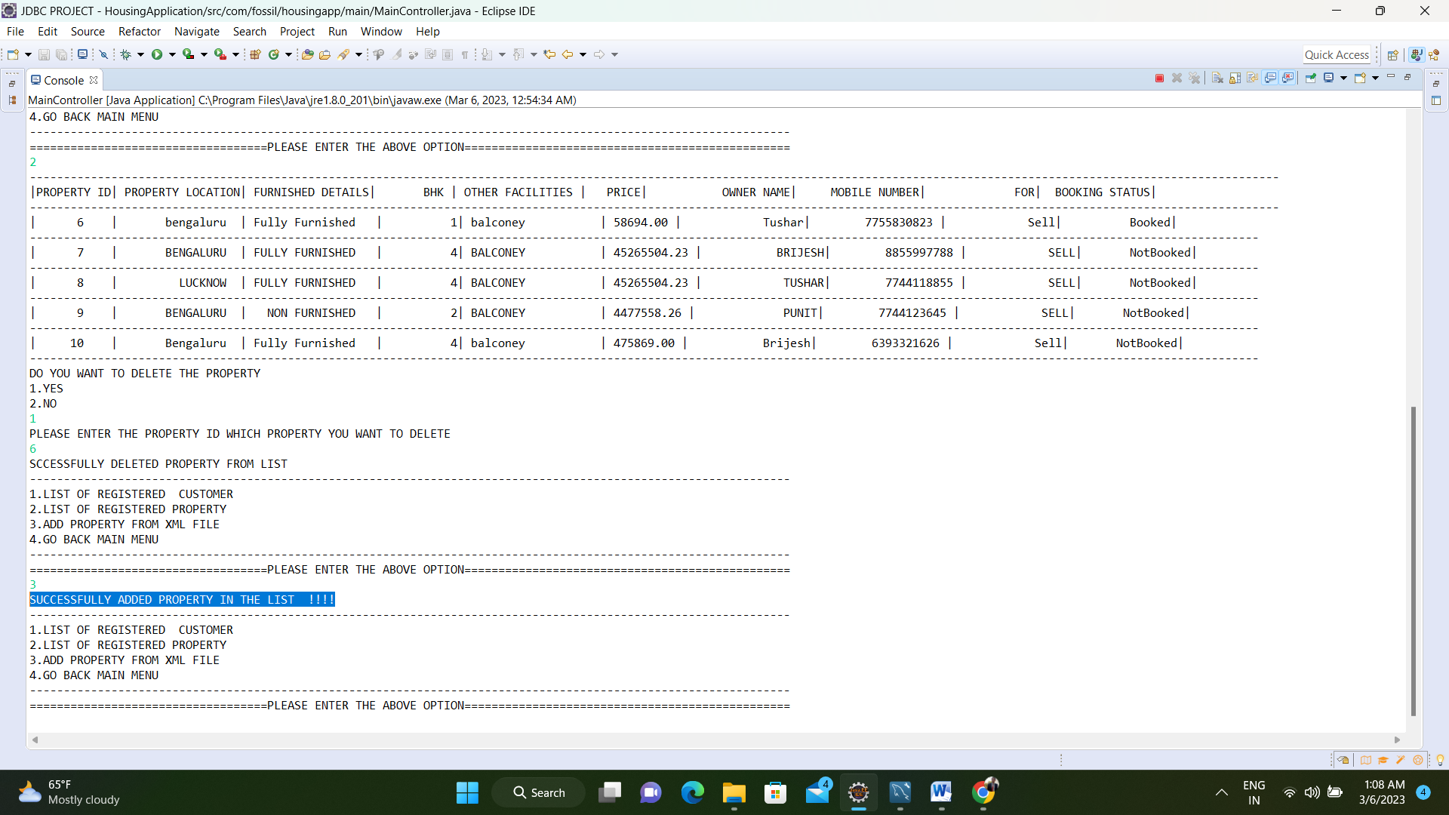

**4.EXIT**

For exit of application you can choose 4 option.